Lab Submission: 6

Student Name: Michael Daly

Course and Section: CST8215 – 362

========================================================================

Lab 6 – Working through the data normalization process

In this Lab, we will use the data provided below (Health History Report). There are four screenshots to be inserted into this submission file, plus your explanation for your modeling decisions.

Grading: Lab 6 is worth 8 marks

========================================================================

**Lab 6 Submission**

Using the sample data below, walk through the normalization phases and submit screenshots and textual explanations for each phase. Remember, you need to show all the columns in every phase.

**HEALTH HISTORY REPORT**

PET ID PET NAME PET TYPE PET AGE OWNER VISIT DATE PROCEDURE

246 ROVER DOG 12 SAM COOK JAN 13/2002 01 - RABIES VACCINATION

MAR 27/2002 10 - EXAMINE and TREAT WOUND

APR 02/2002 05 - HEART WORM TEST

298 SPOT DOG 2 TERRY KIM JAN 21/2002 08 - TETANUS VACCINATION

MAR 10/2002 05 - HEART WORM TEST

341 MORRIS CAT 4 SAM COOK JAN 23/2001 01 - RABIES VACCINATION

JAN 13/2002 01 - RABIES VACCINATION

519 TWEEDY BIRD 2 TERRY KIM APR 30/2002 20 - ANNUAL CHECK UP

APR 30/2002 12 - EYE WASH

**UNF (Denormalized):**

* ***Show me how you would store this data in excel spreadsheet (screenshot of your spreadsheet with data in the columns)***
* ***Provide three problems with working with the data using this method (Insert, Update and Deletion issues).***

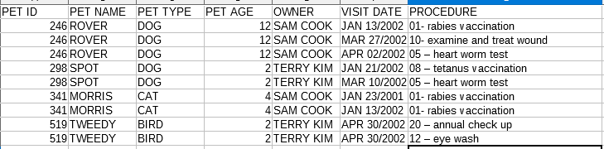

Updating the owner of a pet would require an update of every single entry on every single entry for saod pet to avoid inconsistent and incorrect data.

If a pet name changes every single entry would have to be updated for that pet.

procedures are traced through a code and description in the same column, if it every changes finding each entry would be very difficult and require updates across all entries manually.

Pet types tracked through description could lead to inconsistent descriptions or terminology used to describe the pet type

Pets age every year so either you have to update each entry to track current age or keep potentially out of date age information if an entry gets updated and others don’t/a deletion.

Every time a new procedure is done the pets name, type and owner has to be retyped when inserting a new entry leading to a lot of repeated data that may not be entirely relevant all the time.

Multiple procedures on the same day require multiple full entries of all the same data retyped, and a repeating procedure requires the same thing.

**1NF:**

* ***On a row-by-row basis, list all data elements by table***

***e.g. id, name, type, age --- Pet***

Pet : id,name,type code, age, owner

Pet type: id, description

Owner : id, name

Procedure: code, description

PetProcedure:pet id, procedure id, date

**2NF:**

* ***Identify the primary key for each of the tables you defined in 1NF***

Pet: id

Pet type: id

Owner: id

Procedure: code

PetProcedure:pet id,procedure id, date

**3NF:**

* ***Analyse each of your tables to ensure every attribute depends 100 percent on the primary key you chose***

Pet: Each pet will have a name, an associated type code, an age, and one owner id per id

Pet type: each type of pet will have to have a code to match with the pet type( 1. Dog 2. Cat etc..) to avoid repetition of typing descriptions.

Owner: Each pet owner will have an individual id and name (could do a many to many with pets for pets that have multiple owners, but with information given cannot make that determination)

Procedure: Each possible procedure will have a unique code and description

PetProcedure: Using a unique pet id it will match with a procedure id, that will have a required date to create a composite key. This will allow multiple different procedures on the same date, and repeating procedures allowed across any period of time without conflict.

Using PGMODELER, enter your new tables, add the primary key, data elements and provide a screenshot of your data model

